**BANK LOAN REPORT QUERY DOCUMENT**

1. **BANK LOAN REPORT | SUMMARY**

**KPI’s:**

**1. Total Loan Applications**

SELECT COUNT(id) AS Total_Loan_Applications FROM bank_loan_data



**MTD Loan Applications (Month to date)**

SELECT COUNT(id) AS MTD_Total_Loan_Applications FROM bank_loan_data

WHERE MONTH(issue_date) = 12 AND YEAR(issue_date) = 2021



**PMTD Loan Applications (Previous Month to date MoM)**

SELECT COUNT(id) AS PMTD_Total_Loan_Applications FROM bank_loan_data

WHERE MONTH(issue_date) = 11 AND YEAR(issue_date) = 2021



**2. Total Funded Amount**

SELECT SUM(loan_amount) AS Total_Funded_Amount FROM bank_loan_data



**MTD Total Funded Amount**

SELECT SUM(loan_amount) AS MTD_Total_Funded_Amount FROM bank_loan_data

WHERE MONTH(issue_date) = 12 AND YEAR(issue_date) = 2021



**PMTD Total Funded Amount**

SELECT SUM(loan_amount) AS PMTD_Total_Funded_Amount FROM bank_loan_data

WHERE MONTH(issue_date) = 11 AND YEAR(issue_date) = 2021



**3.Total Amount Received**

SELECT SUM(total_payment) AS Total_Amount_Recived FROM bank_loan_data



**MTD Total Amount Received**

SELECT SUM(total_payment) AS MTD_Total_Amount_Recived FROM bank_loan_data

WHERE MONTH(issue_date) = 12 AND YEAR(issue_date) = 2021



**PMTD Total Amount Received**

SELECT SUM(total_payment) AS PMTD_Total_Amount_Received FROM bank_loan_data

WHERE MONTH(issue_date) = 11 AND YEAR(issue_date) = 2021



**4.Average Interest Rate**

SELECT AVG(int_rate)*100 AS Average_Interest_Rate FROM bank_loan_data



**MTD Average Interest**

SELECT AVG(int_rate)*100 AS MTD_Average_Interest_Rate FROM bank_loan_data

WHERE MONTH(issue_date) = 12 AND YEAR(issue_date) = 2021



**PMTD Average Interest**

SELECT AVG(int_rate)*100 AS PMTD_Average_Interest_Rate FROM bank_loan_data

WHERE MONTH(issue_date) = 11 AND YEAR(issue_date) = 2021



**5.Average Debt-to-Income Ratio (DTI)**

SELECT AVG(dti)*100 AS Average_Debt_to_Income_Ratio FROM bank_loan_data



**MTD Average Debt-to-Income Ratio (DTI)**

SELECT AVG(dti)*100 AS MTD_Average_Debt_to_Income_Ratio FROM bank_loan_data

WHERE MONTH(issue_date) = 12 AND YEAR(issue_date) = 2021



**PMTD Average Debt-to-Income Ratio (DTI)**

SELECT AVG(dti)*100 AS PMTD_Average_Debt_to_Income_Ratio FROM bank_loan_data

WHERE MONTH(issue_date) = 11 AND YEAR(issue_date) = 2021



**GOOD LOAN ISSUED**

**Good Loan Percentage**

SELECT

(COUNT(CASE WHEN loan_status = 'Fully Paid' OR loan_status = 'Current' THEN id END) * 100.0 ) /

count(id) AS Good_Loan_Percentage

FROM bank_loan_data



**Good Loan Applications**

SELECT COUNT(id) AS Good_Loan_Applications FROM bank_loan_data

WHERE loan_status = 'Fully Paid' OR loan_status = 'Current'



**Good Loan Funded Amount**

SELECT SUM(loan_amount) AS Good_Loan_Funded_Amount FROM bank_loan_data

WHERE loan_status = 'Fully Paid' OR loan_status = 'Current'



**Good Loan Amount Received**

SELECT SUM(total_payment) AS Good_Loan_Amount_Received FROM bank_loan_data

WHERE loan_status = 'Fully Paid' OR loan_status = 'Current'



**BAD LOAN ISSUED**

**Bad Loan Percentage**

SELECT (COUNT(CASE WHEN loan_status = 'Charged Off' THEN id END) * 100.0) /

COUNT(id) AS Bad_Loan_Percentage

FROM bank_loan_data



**Bad Loan Applications**

SELECT COUNT(id) AS Bad_Loan_Applications FROM bank_loan_data

WHERE loan_status = 'Charged Off'



**Bad Loan Funded Amount**

SELECT SUM(loan_amount) AS Bad_Loan_Funded_Amount FROM bank_loan_data

WHERE loan_status = 'Charged Off'



**Bad Loan Amount Received**

SELECT SUM(total_payment) AS Bad_Loan_Amount_Received FROM bank_loan_data

WHERE loan_status = 'Charged Off'



**LOAN STATUS**

SELECT

loan_status,

COUNT(id) AS Total_Loan_Applications,

SUM(loan_amount) AS Total_Funded_Amount,

SUM(total_payment) AS Total_Amount_Received,

AVG(int_rate * 100) AS Average_Interest_Rate,

AVG(dti * 100) AS Average_Debt_to_Income_Ratio_DTI

FROM

bank_loan_data

GROUP BY

loan_status



SELECT

loan_status,

SUM(loan_amount) AS MTD_Funded_Amount,

SUM(total_payment) AS MTD_Amount_Received

FROM bank_loan_data

WHERE MONTH(issue_date) = 12 AND YEAR(issue_date) = 2021

GROUP BY loan_status

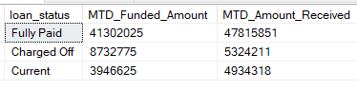

1. **BANK LOAN REPORT | OVERVIEW**

**MONTH**

SELECT

MONTH(issue_date) AS Month_Number,

DATENAME(MONTH, issue_date) AS Month_Name,

COUNT(id) AS Total_Loan_Applications,

SUM(loan_amount) AS Total_Funded_Amount,

SUM(total_payment) AS Total_Amount_Received

FROM bank_loan_data

GROUP BY MONTH(issue_date), DATENAME(MONTH, issue_date)

ORDER BY MONTH(issue_date)

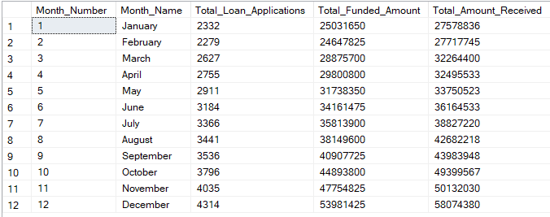

**STATE**

SELECT

address_state AS State,

COUNT(id) AS Total_Loan_Applications,

SUM(loan_amount) AS Total_Funded_Amount,

SUM(total_payment) AS Total_Amount_Received

FROM bank_loan_data

GROUP BY address_state

ORDER BY address_state

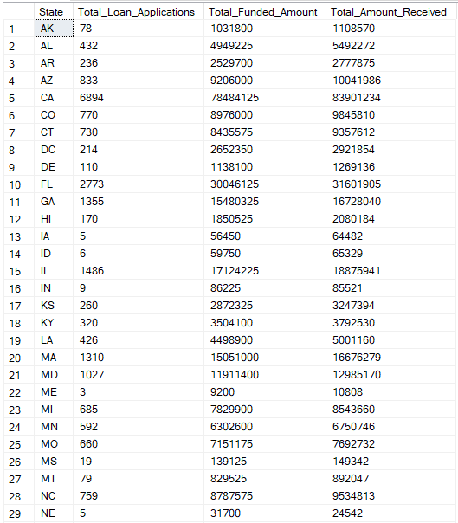

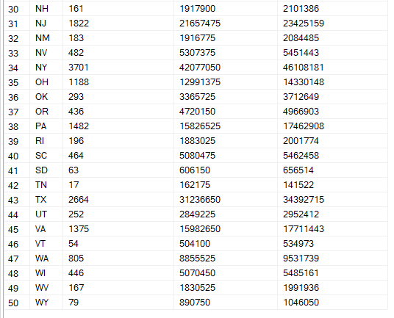

**TERM**

SELECT

term AS Term,

COUNT(id) AS Total_Loan_Applications,

SUM(loan_amount) AS Total_Funded_Amount,

SUM(total_payment) AS Total_Amount_Received

FROM bank_loan_data

GROUP BY term

ORDER BY term

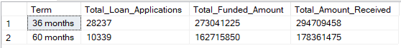

**EMPLOYEE LENGTH**

SELECT

emp_length AS Employee_length,

COUNT(id) AS Total_Loan_Applications,

SUM(loan_amount) AS Total_Funded_Amount,

SUM(total_payment) AS Total_Amount_Received

FROM bank_loan_data

GROUP BY emp_length

ORDER BY emp_length

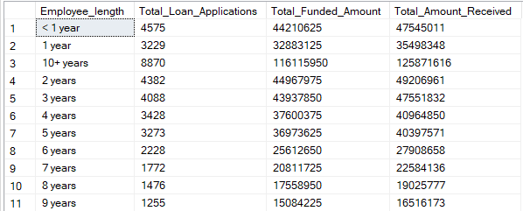

**PURPOSE**

SELECT

purpose AS PURPOSE,

COUNT(id) AS Total_Loan_Applications,

SUM(loan_amount) AS Total_Funded_Amount,

SUM(total_payment) AS Total_Amount_Received

FROM bank_loan_data

GROUP BY purpose

ORDER BY purpose

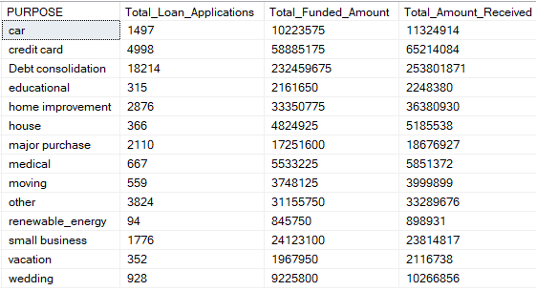

**HOME OWNERSHIP**

SELECT

home_ownership AS Home_Ownership,

COUNT(id) AS Total_Loan_Applications,

SUM(loan_amount) AS Total_Funded_Amount,

SUM(total_payment) AS Total_Amount_Received

FROM bank_loan_data

GROUP BY home_ownership

ORDER BY home_ownership

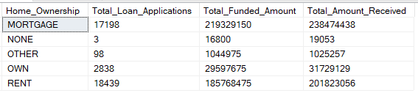

*Note: We have applied multiple Filters on all the dashboards. You can check the results for the filters as well by modifying the query and comparing the results.*

*For e.g*

*See the results when we hit the Grade A in the filters for dashboards.*

*SELECT*

*purpose AS PURPOSE,*

*COUNT(id) AS Total_Loan_Applications,*

*SUM(loan_amount) AS Total_Funded_Amount,*

*SUM(total_payment) AS Total_Amount_Received*

*FROM bank_loan_data*

*WHERE grade = 'A'*

*GROUP BY purpose*

*ORDER BY purpose*